Maintenance for PCX Bermad pilot



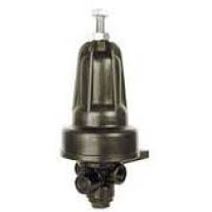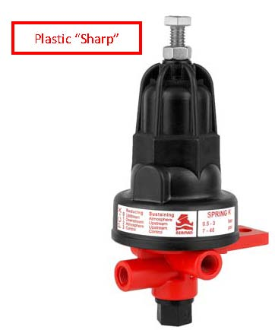

Introduction

The Bermad PCX three way pilots are positioning pilots which are typically used for pressure reduction or sustaining functions on irrigation valves. The purpose of this document is to give users a guide to keeping the pilot operational and serviced correctly.

Suggested maintenance Schedule

We suggest prior to each irrigation season while the valve has been dormant for some time to consider the following :

1. De-pressurise the pilot from the valve to enable work to be carried out on the internals.
2. Remove the cover (31B) from the body. Check that the cover drain hole is not blocked in the plastic housing by mud wasps or mud so that the cover can be vented to atmosphere.
3. Remove the spring (17) and spring guide (18) from the cover. If the spring is rusted, then replace with a new correct spring. Make sure the spring guide is not damaged.
4. Lever off the plastic diaphragm retainer off the diaphragm assy gently with a screw driver taking care not to damage the diaphragm.
5. Remove the diaphragm assy with the shaft (30). Inspect the O rings to make sure they are in good working order and apply a small amount of silicon grease for lubricant to the shaft. Make sure the diaphragm has no tears or splits and fit new parts as required.
6. Make sure all the ports in the pilot body (32) are completely clear and there is no mud or blockages. Also check the tubes that attach to the pilot and make sure they are all in good working order without kinks or splits. Take care especially with the port 1 (sense port) as this is stationary water and should be clear to the underside of the diaphragm at all times. Flush the body with clean water to make sure there are no signs of mud.
7. Re assemble the pilot as disassembled and be sure to fit the plastic retainer back on the diaphragm the correct way up, otherwise the pilot will not work.
8. For setting of the pilot, manuals, drawings, watch video’s on valve setting on our web page to obtain the correct settings :

See data link on bermad.com.au:

Reducing : <http://www.bermad.com.au/products/pressure-reducing-valve-ir-420-kxz/>

Sustaining : <http://www.bermad.com.au/products/pressure-sustaining-valve-ir-430-xz-pcp/>

Red / Sust : <http://www.bermad.com.au/products/pressure-reducing-sustaining-valve-ir-423-kxz/>

